[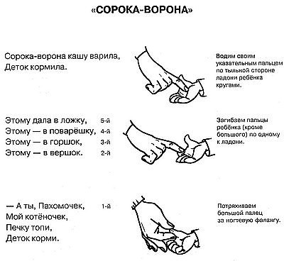](https://ok.ru/dk?cmd=PopLayerPhoto&st.layer.cmd=PopLayerPhotoOuter&st.layer.type=GROUP&st.layer.revNav=off&st.layer.limitedUi=false&st.layer.closeLayers=off&st.layer.sphotoIds=870999825644;870999825388;870999825132;870999823852;870999835116;870999840748;870999840492;870999847660;870999864556&st.layer.showNav=on&st.layer.photoAlbumId=52975483224300&st.layer.epm=off&st.layer.photoId=870999825644&st.layer.opl=off&st.layer.navStartPhotoId=870999825644&st.layer.sbd=off&st.cmd=userMain&st._aid=GroupTopicLayer_openPhotoLayer)

[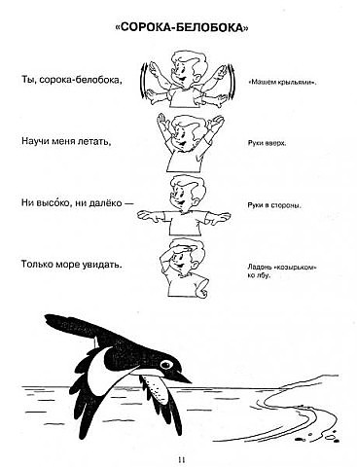](https://ok.ru/dk?cmd=PopLayerPhoto&st.layer.cmd=PopLayerPhotoOuter&st.layer.type=GROUP&st.layer.revNav=off&st.layer.limitedUi=false&st.layer.closeLayers=off&st.layer.sphotoIds=870999825644;870999825388;870999825132;870999823852;870999835116;870999840748;870999840492;870999847660;870999864556&st.layer.showNav=on&st.layer.photoAlbumId=52975483224300&st.layer.epm=off&st.layer.photoId=870999825388&st.layer.opl=off&st.layer.navStartPhotoId=870999825388&st.layer.sbd=off&st.cmd=userMain&st._aid=GroupTopicLayer_openPhotoLayer)

[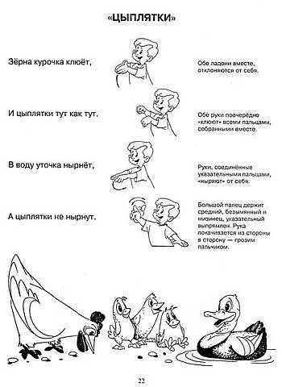](https://ok.ru/dk?cmd=PopLayerPhoto&st.layer.cmd=PopLayerPhotoOuter&st.layer.type=GROUP&st.layer.revNav=off&st.layer.limitedUi=false&st.layer.closeLayers=off&st.layer.sphotoIds=870999825644;870999825388;870999825132;870999823852;870999835116;870999840748;870999840492;870999847660;870999864556&st.layer.showNav=on&st.layer.photoAlbumId=52975483224300&st.layer.epm=off&st.layer.photoId=870999825132&st.layer.opl=off&st.layer.navStartPhotoId=870999825132&st.layer.sbd=off&st.cmd=userMain&st._aid=GroupTopicLayer_openPhotoLayer)

[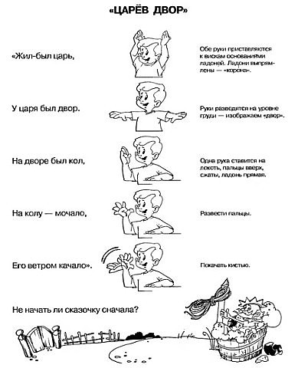](https://ok.ru/dk?cmd=PopLayerPhoto&st.layer.cmd=PopLayerPhotoOuter&st.layer.type=GROUP&st.layer.revNav=off&st.layer.limitedUi=false&st.layer.closeLayers=off&st.layer.sphotoIds=870999825644;870999825388;870999825132;870999823852;870999835116;870999840748;870999840492;870999847660;870999864556&st.layer.showNav=on&st.layer.photoAlbumId=52975483224300&st.layer.epm=off&st.layer.photoId=870999823852&st.layer.opl=off&st.layer.navStartPhotoId=870999823852&st.layer.sbd=off&st.cmd=userMain&st._aid=GroupTopicLayer_openPhotoLayer)

[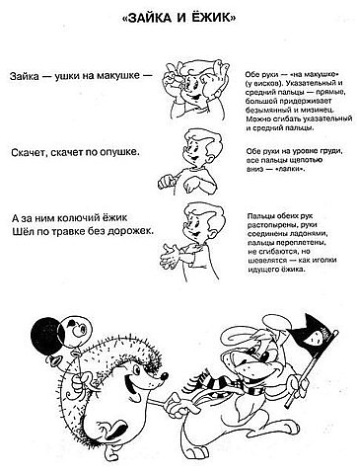](https://ok.ru/dk?cmd=PopLayerPhoto&st.layer.cmd=PopLayerPhotoOuter&st.layer.type=GROUP&st.layer.revNav=off&st.layer.limitedUi=false&st.layer.closeLayers=off&st.layer.sphotoIds=870999825644;870999825388;870999825132;870999823852;870999835116;870999840748;870999840492;870999847660;870999864556&st.layer.showNav=on&st.layer.photoAlbumId=52975483224300&st.layer.epm=off&st.layer.photoId=870999835116&st.layer.opl=off&st.layer.navStartPhotoId=870999835116&st.layer.sbd=off&st.cmd=userMain&st._aid=GroupTopicLayer_openPhotoLayer)

[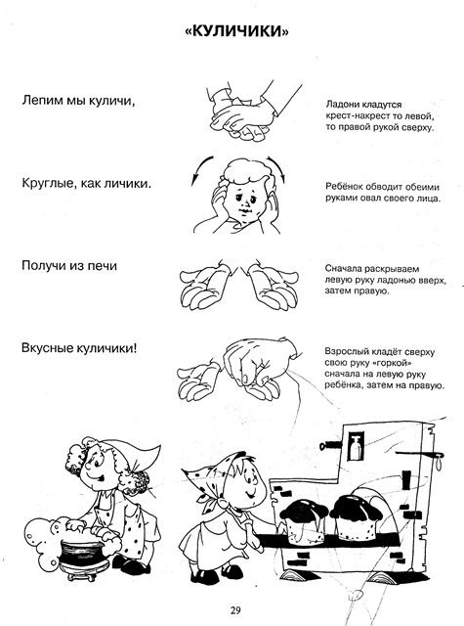](https://ok.ru/dk?cmd=PopLayerPhoto&st.layer.cmd=PopLayerPhotoOuter&st.layer.type=GROUP&st.layer.revNav=off&st.layer.limitedUi=false&st.layer.closeLayers=off&st.layer.sphotoIds=870999825644;870999825388;870999825132;870999823852;870999835116;870999840748;870999840492;870999847660;870999864556&st.layer.showNav=on&st.layer.photoAlbumId=52975483224300&st.layer.epm=off&st.layer.photoId=870999840748&st.layer.opl=off&st.layer.navStartPhotoId=870999840748&st.layer.sbd=off&st.cmd=userMain&st._aid=GroupTopicLayer_openPhotoLayer)

[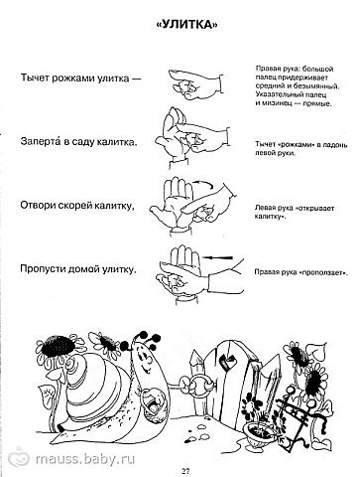](https://ok.ru/dk?cmd=PopLayerPhoto&st.layer.cmd=PopLayerPhotoOuter&st.layer.type=GROUP&st.layer.revNav=off&st.layer.limitedUi=false&st.layer.closeLayers=off&st.layer.sphotoIds=870999825644;870999825388;870999825132;870999823852;870999835116;870999840748;870999840492;870999847660;870999864556&st.layer.showNav=on&st.layer.photoAlbumId=52975483224300&st.layer.epm=off&st.layer.photoId=870999840492&st.layer.opl=off&st.layer.navStartPhotoId=870999840492&st.layer.sbd=off&st.cmd=userMain&st._aid=GroupTopicLayer_openPhotoLayer)

[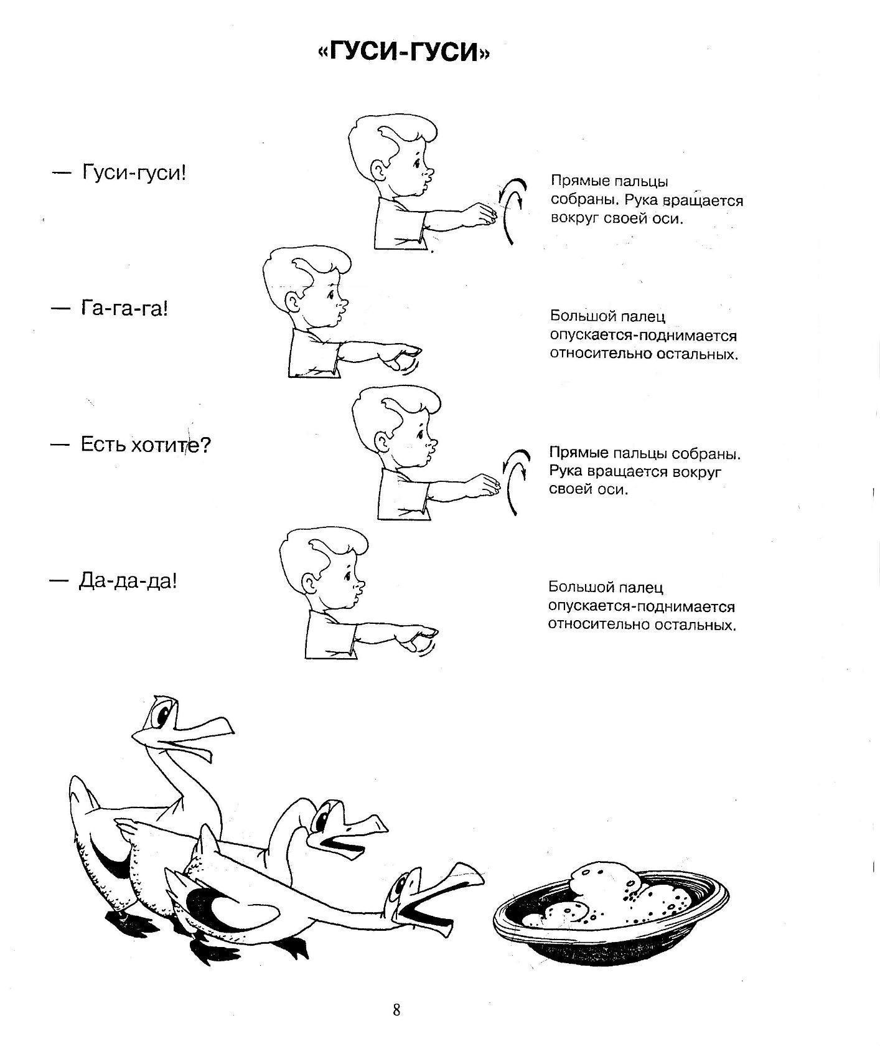](https://ok.ru/dk?cmd=PopLayerPhoto&st.layer.cmd=PopLayerPhotoOuter&st.layer.type=GROUP&st.layer.revNav=off&st.layer.limitedUi=false&st.layer.closeLayers=off&st.layer.sphotoIds=870999825644;870999825388;870999825132;870999823852;870999835116;870999840748;870999840492;870999847660;870999864556&st.layer.showNav=on&st.layer.photoAlbumId=52975483224300&st.layer.epm=off&st.layer.photoId=870999847660&st.layer.opl=off&st.layer.navStartPhotoId=870999847660&st.layer.sbd=off&st.cmd=userMain&st._aid=GroupTopicLayer_openPhotoLayer)

[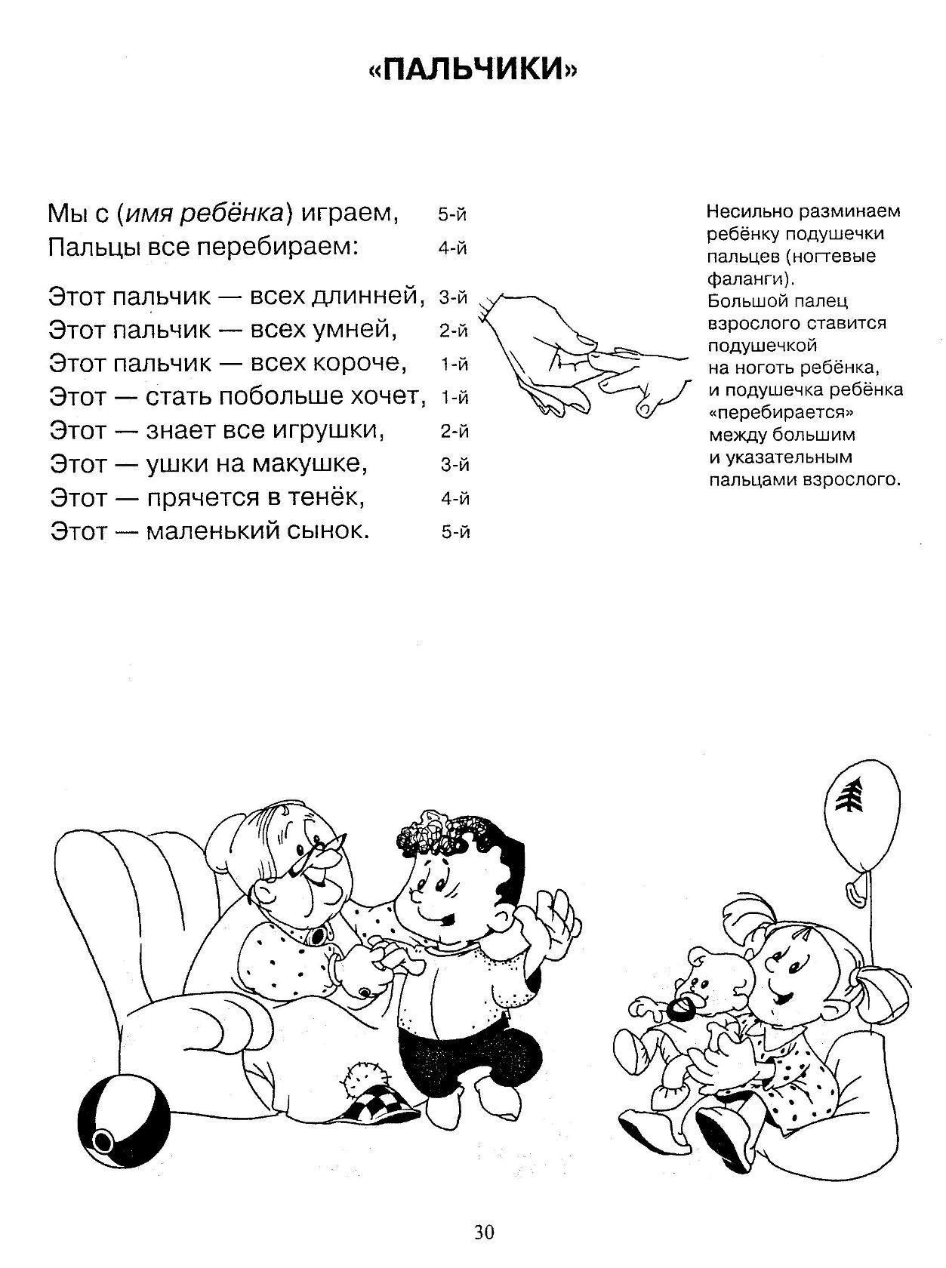](https://ok.ru/dk?cmd=PopLayerPhoto&st.layer.cmd=PopLayerPhotoOuter&st.layer.type=GROUP&st.layer.revNav=off&st.layer.limitedUi=false&st.layer.closeLayers=off&st.layer.sphotoIds=870999825644;870999825388;870999825132;870999823852;870999835116;870999840748;870999840492;870999847660;870999864556&st.layer.showNav=on&st.layer.photoAlbumId=52975483224300&st.layer.epm=off&st.layer.photoId=870999864556&st.layer.opl=off&st.layer.navStartPhotoId=870999864556&st.layer.sbd=off&st.cmd=userMain&st._aid=GroupTopicLayer_openPhotoLayer)