Картотека игр на развитие словарного запаса

[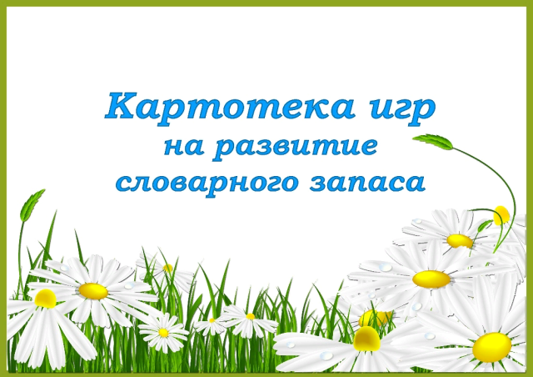](https://ok.ru/dk?cmd=PopLayerPhoto&st.layer.cmd=PopLayerPhotoOuter&st.layer.type=GROUP&st.layer.revNav=off&st.layer.limitedUi=false&st.layer.closeLayers=off&st.layer.sphotoIds=871826546181;871826547973;871826553093;871826556165;871826557445&st.layer.showNav=on&st.layer.photoAlbumId=53823353978885&st.layer.epm=off&st.layer.photoId=871826546181&st.layer.opl=off&st.layer.navStartPhotoId=871826546181&st.layer.sbd=off&st.cmd=userMain&st._aid=GroupTopicLayer_openPhotoLayer)

[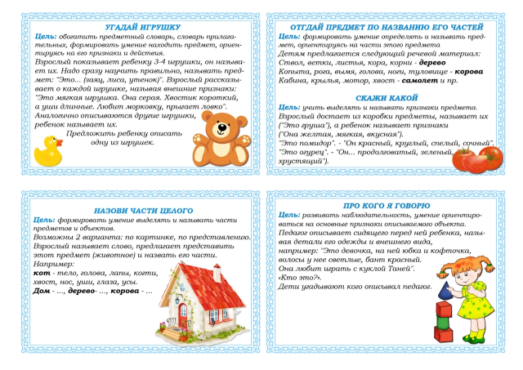](https://ok.ru/dk?cmd=PopLayerPhoto&st.layer.cmd=PopLayerPhotoOuter&st.layer.type=GROUP&st.layer.revNav=off&st.layer.limitedUi=false&st.layer.closeLayers=off&st.layer.sphotoIds=871826546181;871826547973;871826553093;871826556165;871826557445&st.layer.showNav=on&st.layer.photoAlbumId=53823353978885&st.layer.epm=off&st.layer.photoId=871826547973&st.layer.opl=off&st.layer.navStartPhotoId=871826547973&st.layer.sbd=off&st.cmd=userMain&st._aid=GroupTopicLayer_openPhotoLayer)

[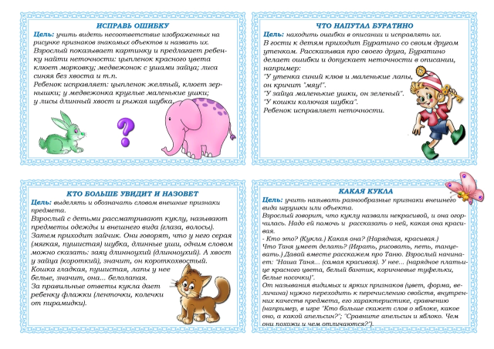](https://ok.ru/dk?cmd=PopLayerPhoto&st.layer.cmd=PopLayerPhotoOuter&st.layer.type=GROUP&st.layer.revNav=off&st.layer.limitedUi=false&st.layer.closeLayers=off&st.layer.sphotoIds=871826546181;871826547973;871826553093;871826556165;871826557445&st.layer.showNav=on&st.layer.photoAlbumId=53823353978885&st.layer.epm=off&st.layer.photoId=871826553093&st.layer.opl=off&st.layer.navStartPhotoId=871826553093&st.layer.sbd=off&st.cmd=userMain&st._aid=GroupTopicLayer_openPhotoLayer)

[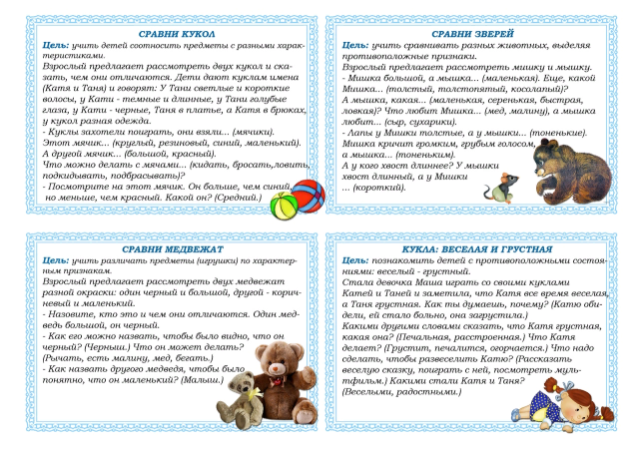](https://ok.ru/dk?cmd=PopLayerPhoto&st.layer.cmd=PopLayerPhotoOuter&st.layer.type=GROUP&st.layer.revNav=off&st.layer.limitedUi=false&st.layer.closeLayers=off&st.layer.sphotoIds=871826546181;871826547973;871826553093;871826556165;871826557445&st.layer.showNav=on&st.layer.photoAlbumId=53823353978885&st.layer.epm=off&st.layer.photoId=871826556165&st.layer.opl=off&st.layer.navStartPhotoId=871826556165&st.layer.sbd=off&st.cmd=userMain&st._aid=GroupTopicLayer_openPhotoLayer)

[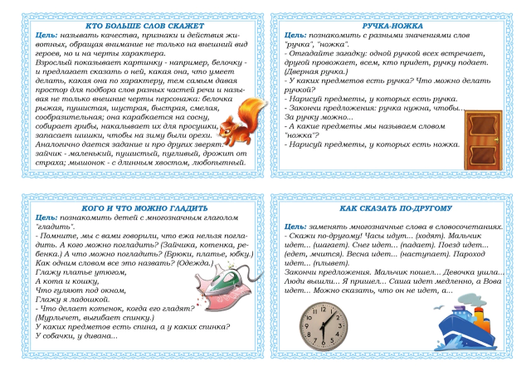](https://ok.ru/dk?cmd=PopLayerPhoto&st.layer.cmd=PopLayerPhotoOuter&st.layer.type=GROUP&st.layer.revNav=off&st.layer.limitedUi=false&st.layer.closeLayers=off&st.layer.sphotoIds=871826546181;871826547973;871826553093;871826556165;871826557445&st.layer.showNav=on&st.layer.photoAlbumId=53823353978885&st.layer.epm=off&st.layer.photoId=871826557445&st.layer.opl=off&st.layer.navStartPhotoId=871826557445&st.layer.sbd=off&st.cmd=userMain&st._aid=GroupTopicLayer_openPhotoLayer)